LAMBDA & API GATEWAY

LAMBDA function creation:

Steps:
Go to AWS ConsoleSearch Lambda in servicesClick Create Function
Choose Author from Scratch Function Name: lambda-1
Runtime → Python 3.12
Architecture → x86_64
Permissions → Create new role with basic Lambda permissions
Click Create Function

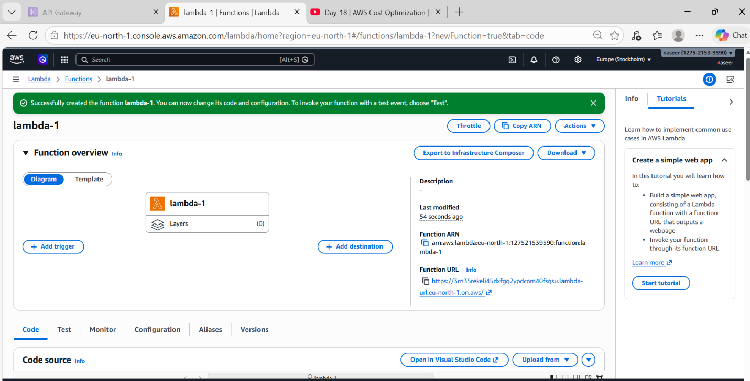

Now we write code to run programs.
- Hello World Lambda
Basic Lambda execution test.
Code
def lambda_handler(event, context):
message = "Hello from AWS Lambda!"
return {
'statusCode': 200,
'body': message
}
Deploy The Code First
And Next Test
Output appears in Execution Results
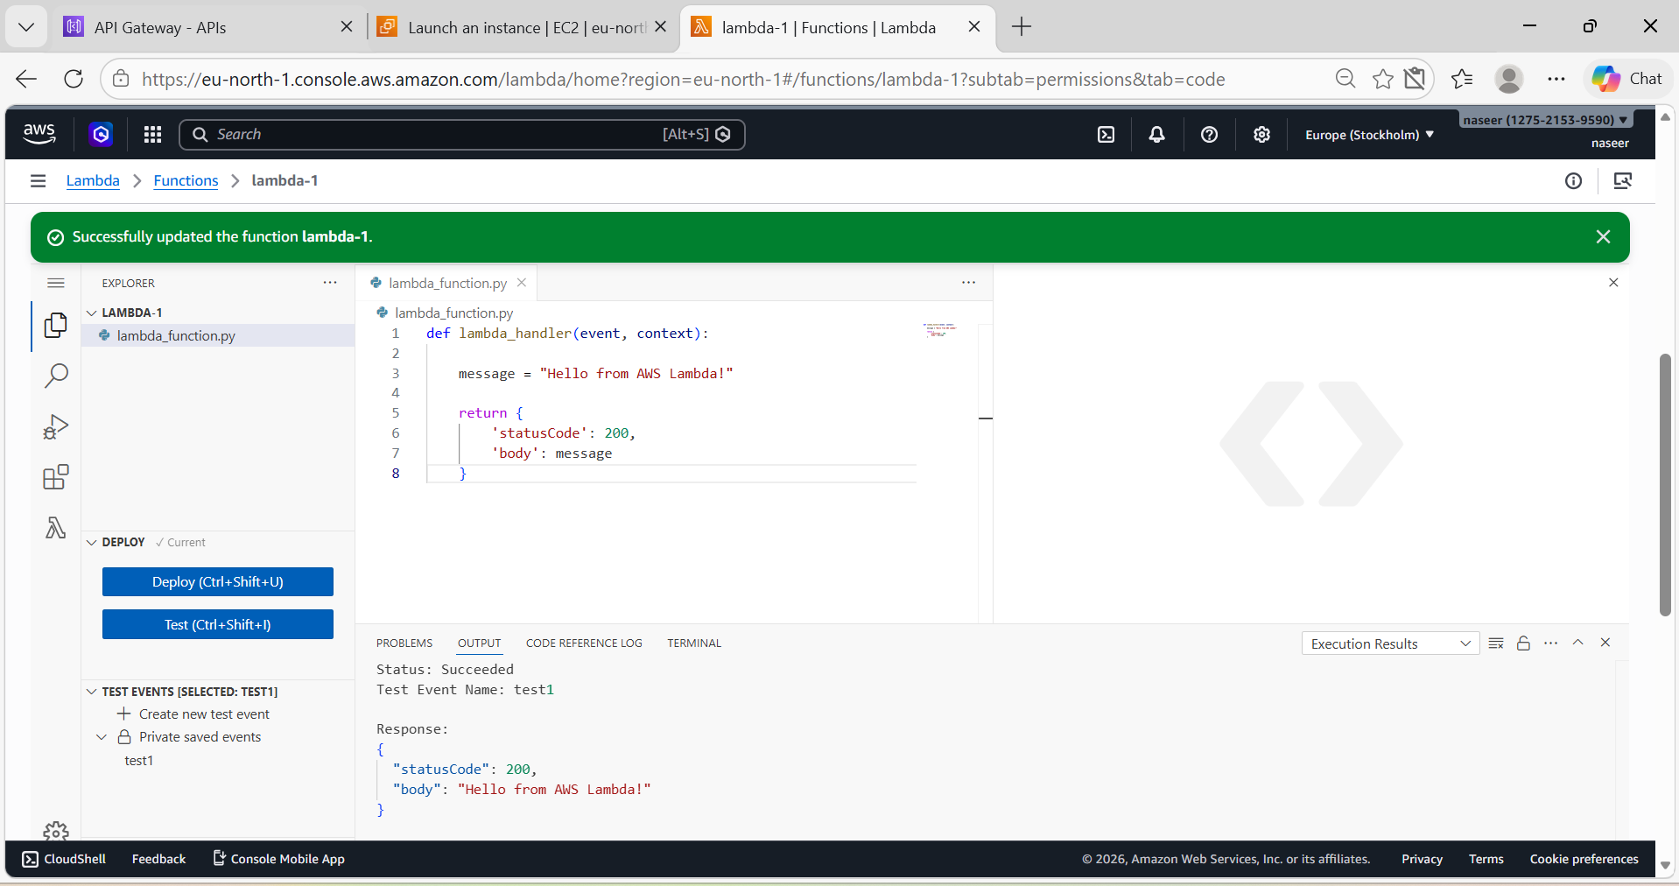
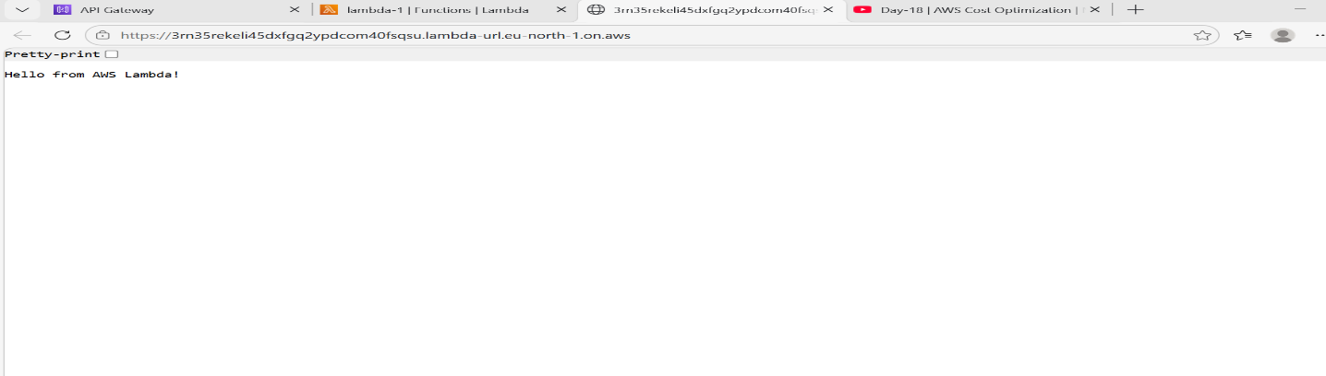
- Add Two Numbers

Purpose
Perform arithmetic operations using Lambda.
Code
import json
def lambda_handler(event, context):
num1 = event.get('num1', 233)
num2 = event.get('num2', 553)
result = num1 + num2
return {
"statusCode": 200,
"body": json.dumps(result)
}
Test Event
{}
Output
786
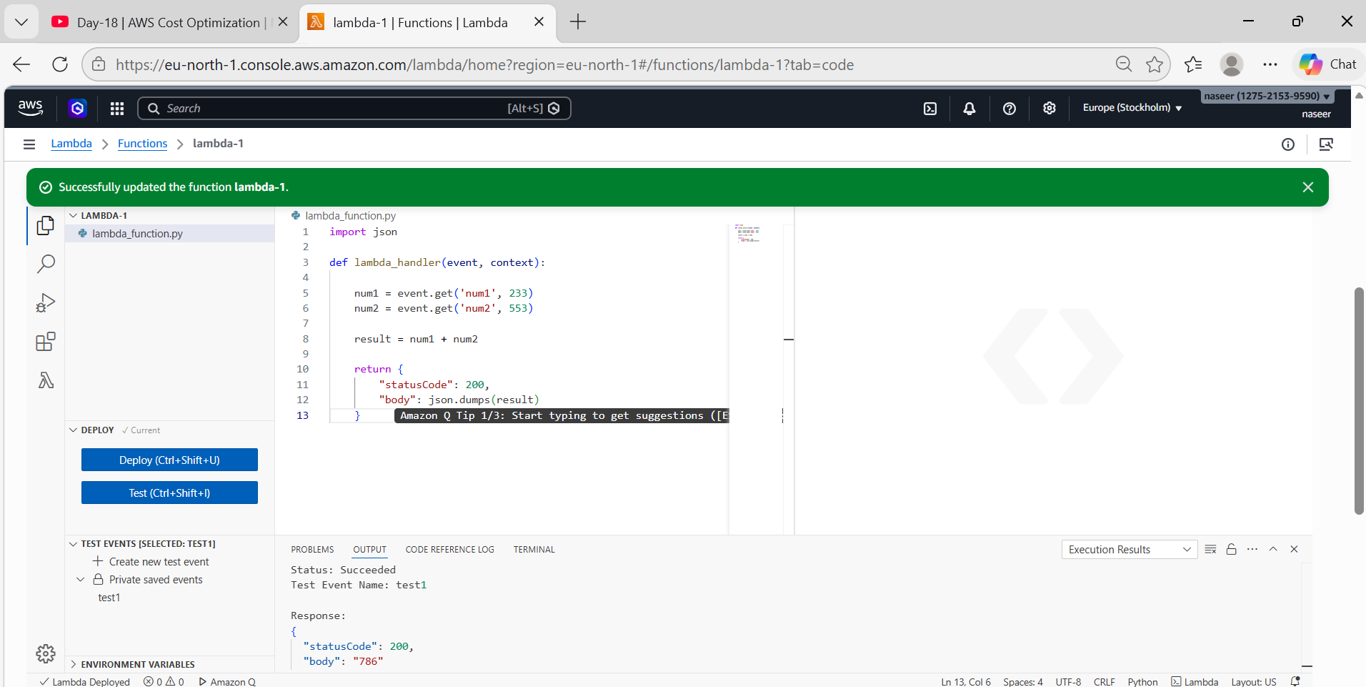
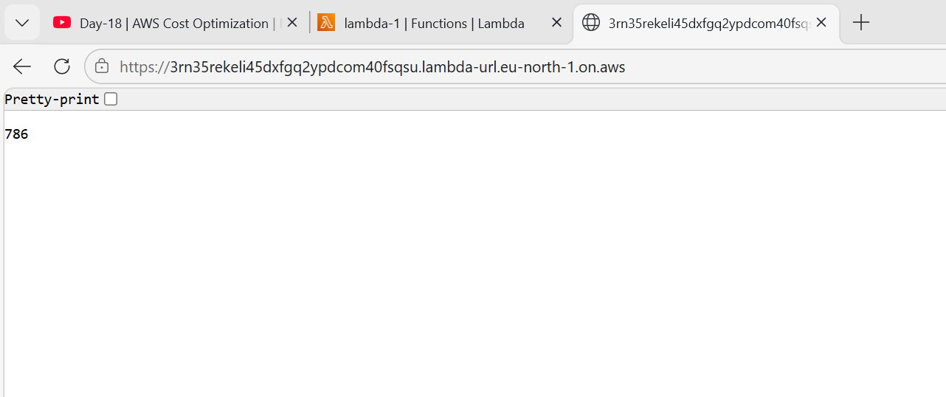

Correct Lambda Execution Flow
Test Event
↓
Event JSON
↓
Lambda receives event
↓
Extract num1 and num2
↓
Add numbers
↓
Return result

- S3 File Upload Trigger Lambda
Automatically execute Lambda when a file uploads to S3
Steps:
- Create S3 Bucket
AWS ConsoleSearch S3Click Create Bucket Bucket Name: lambda-s3-bucket
Region: eu-north-1Block public access: EnabledClick Create Bucket
Add S3 Permission to Lambda
Go to Configuration → Permissions
Role name → Click role
Add permissions → Attach policy
Search → AmazonS3ReadOnlyAccess
Attach
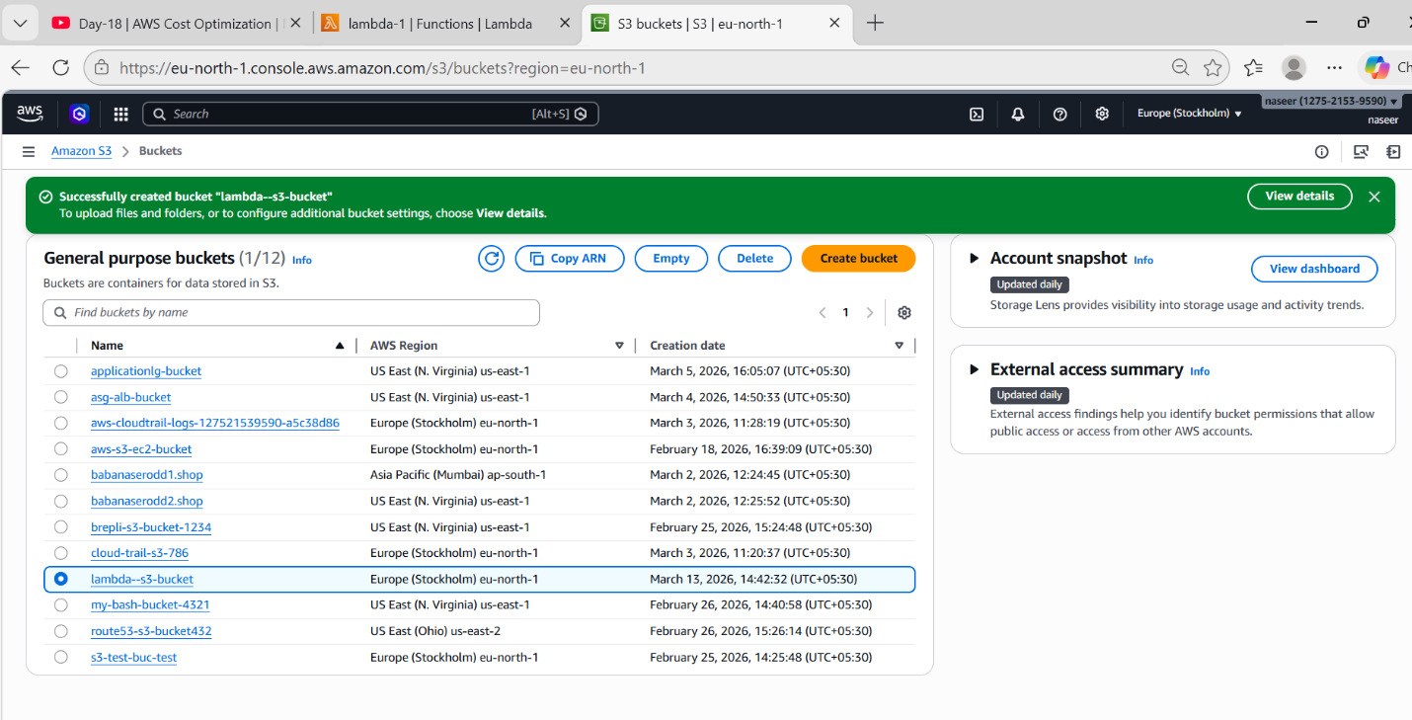
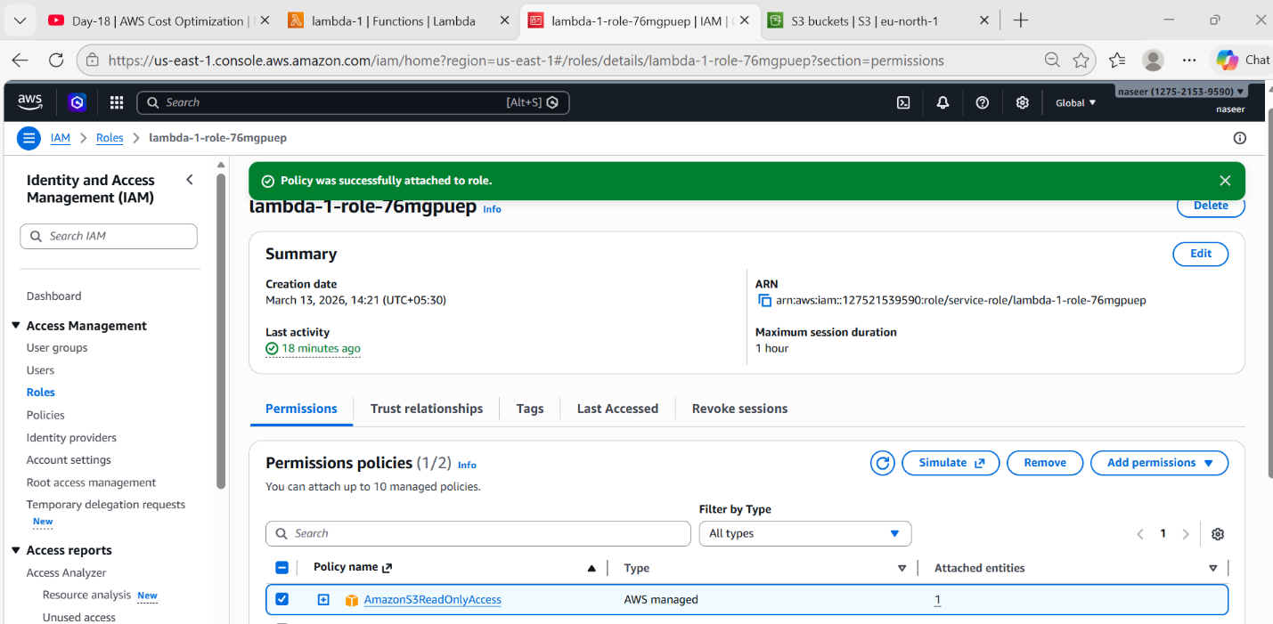

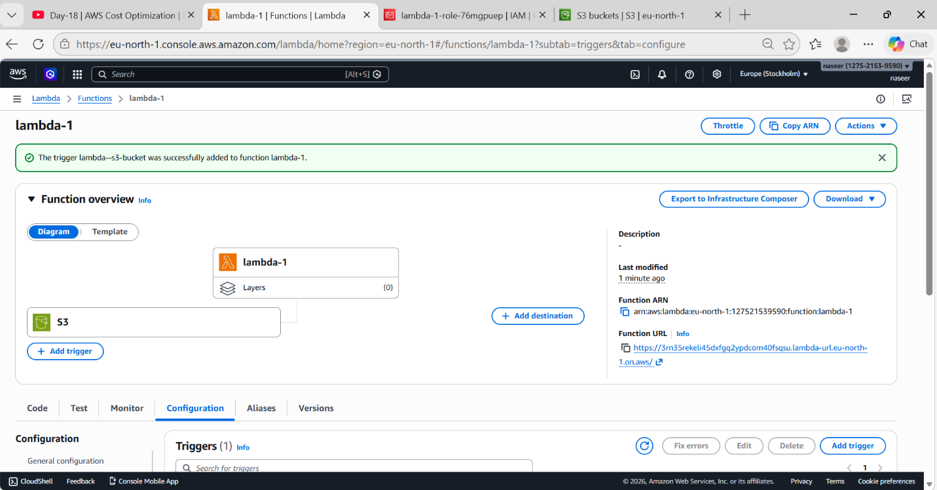
- Upload Test File
Go to S3 bucket(lambda-s3-bucket)Upload filetest.txt
- Check Logs
Open Lambda → Monitor → View logs in CloudWatch
You should see logs like:
Bucket Name: lambda-s3-bucket
File Uploaded: test.txt
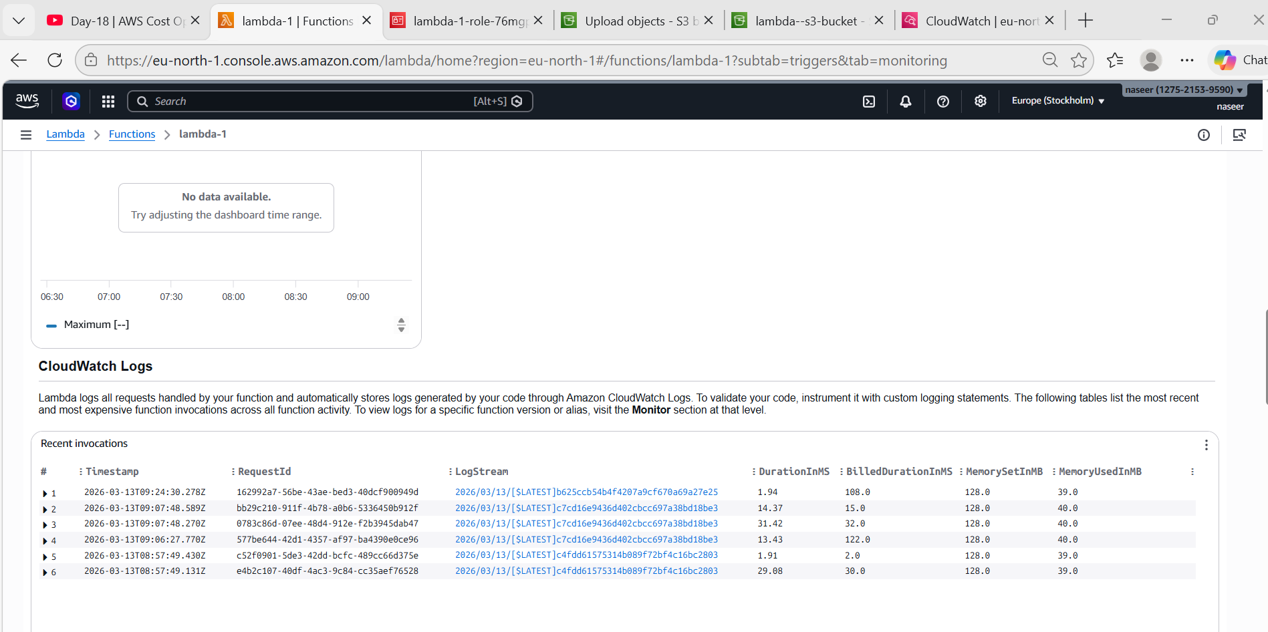
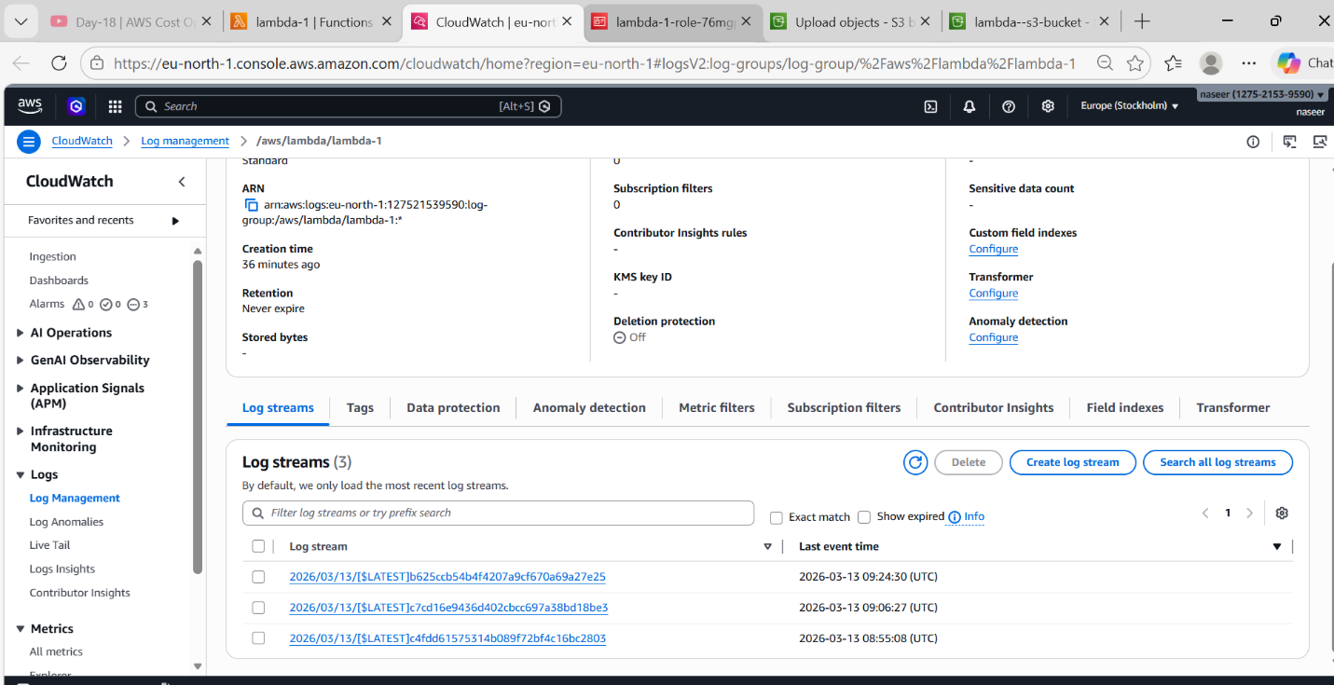

How the Flow Works
User uploads file
↓
S3 Bucket
(lambda-trigger-bucket777)
↓
S3 Event Trigger
↓
Lambda Function
↓
CloudWatch Logs
4) API Gateway + Lambda
Purpose
Create REST API using Lambda.
Lambda Code
import json
def lambda_handler(event, context):
name = "Naseer baba"
if event.get("queryStringParameters"):
name = event["queryStringParameters"].get("name", "Guest")
message = "Hello " + name
return {
"statusCode": 200,
"body": json.dumps(message)
}
Steps
- Create Lambda
- Go to Add Trigger
- Select API Gateway
Options:
Option | Value
API Type | HTTP API
Security | Open
Click Add
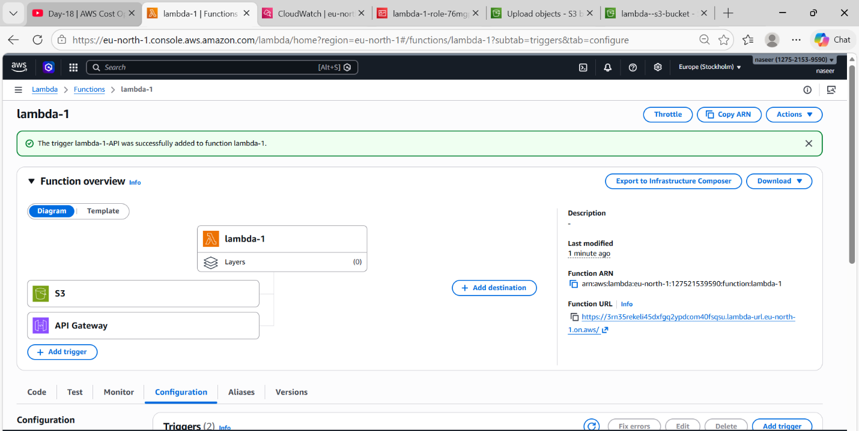

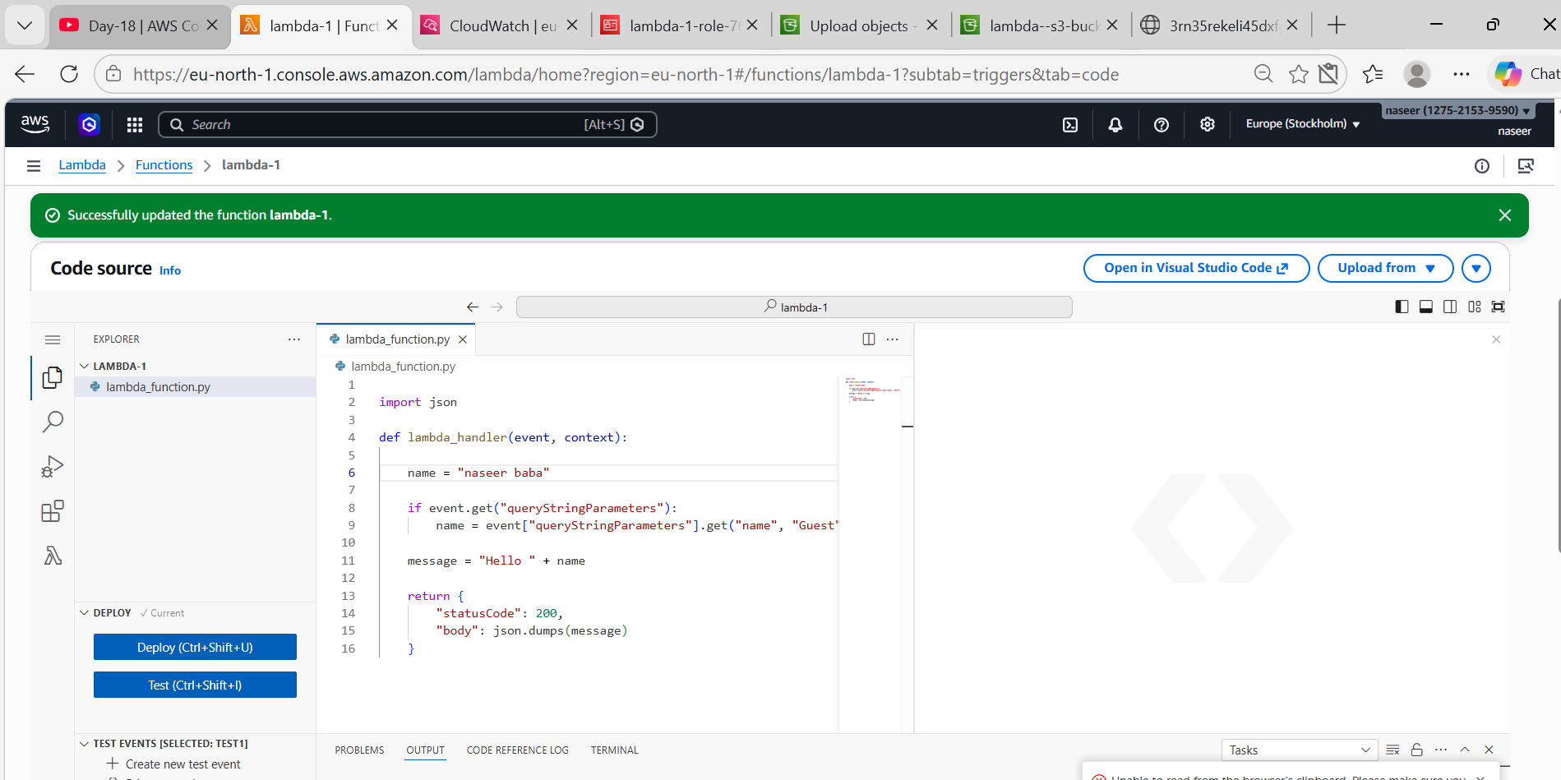
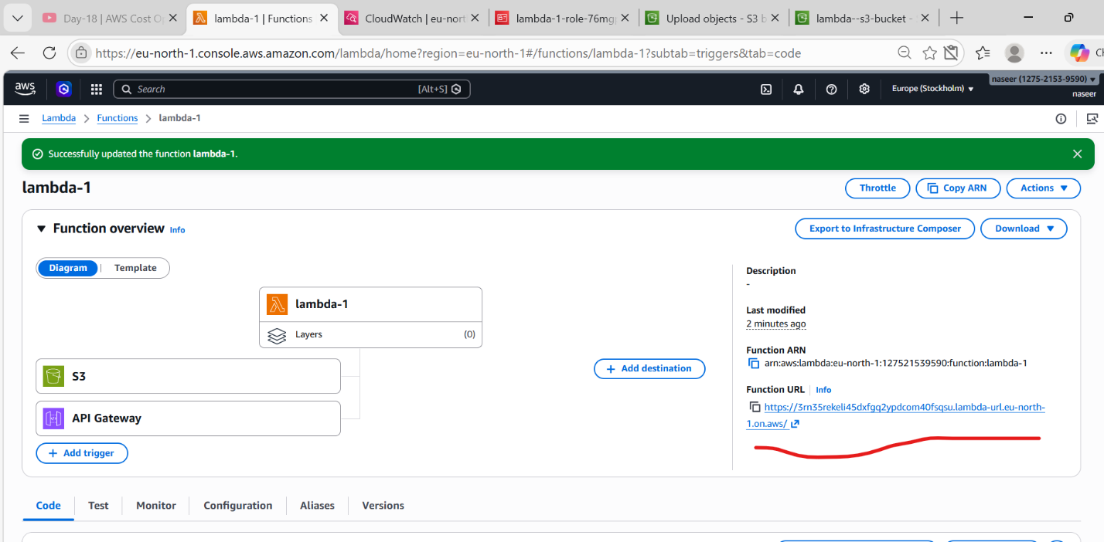
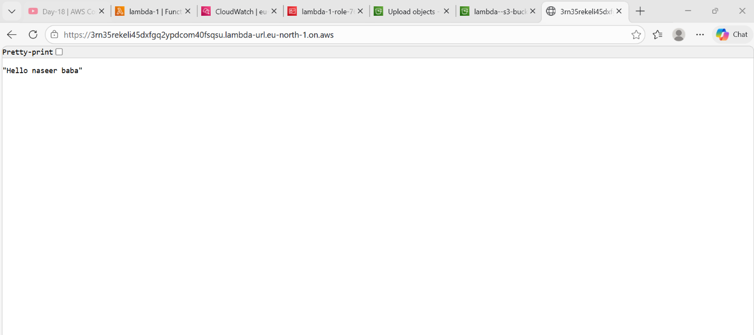
Test
Open generated URL:
Output comes

Architecture
Client
↓
API Gateway
↓
Lambda
↓
Response
5) AWS Lambda to Launch EC2 Instances.
Steps:
- Find Correct AMI ID
Open AWS ConsoleGo to EC2Click Launch Instance
Select Amazon Linux 2Copy the AMI ID(ami-0aaa636894689fa47)
- Create Key Pair
Go to EC2 DashboardClick Key PairsClick Create Key Pair
Fill details:
Name:key.jenkins
Type: RSA
Format: .pem
Click Create
File downloaded:
Key.jenkins
This is used for SSH login to EC2.
- Create IAM Role for Lambda
Lambda must have permission to create EC2 instances.
Go to IAMClick RolesClick Create RoleSelect: AWS Service → Lambda
Attach policy: AmazonEC2FullAccess
Role name: LambdaEC2RoleClick Create Role.
- Add Python Code
Replace the default code with this:
import boto3
ec2 = boto3.resource('ec2', region_name='eu-north-1')
def lambda_handler(event, context):
instances = ec2.create_instances(
ImageId=' ami-0aaa636894689fa47 ',
MinCount=2,
MaxCount=3,
InstanceType='t3.micro',
KeyName='key.jenkins'
)
print("Instances launched")
return {
'statusCode': 200,
'message': 'EC2 instances created successfully'
}
Click Deploy.
And after Click on Test
Lambda will run and create 3 EC2 instances.
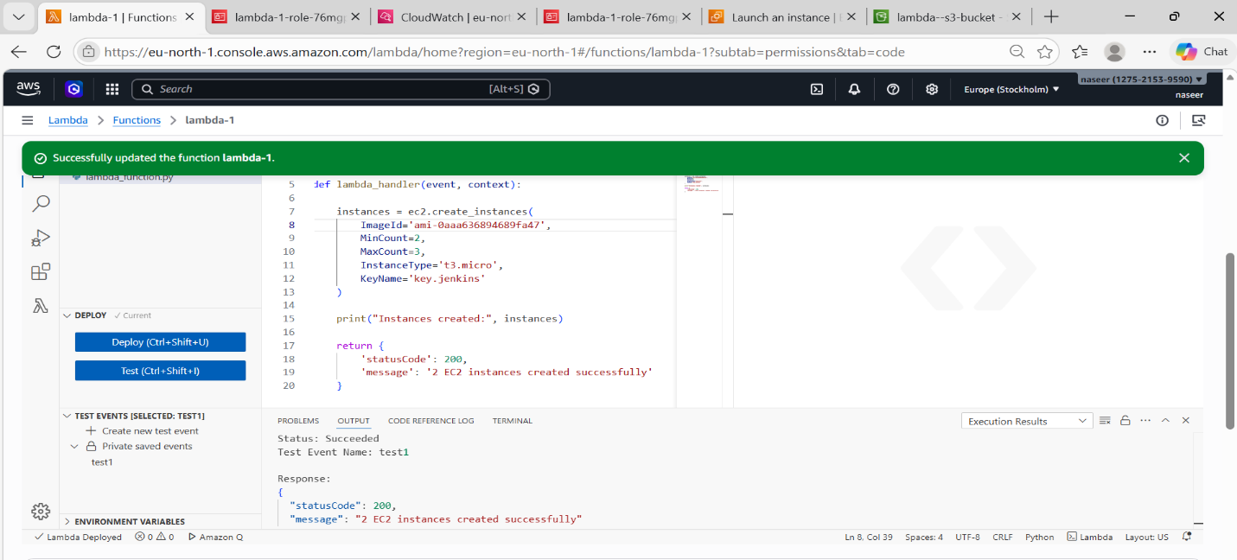
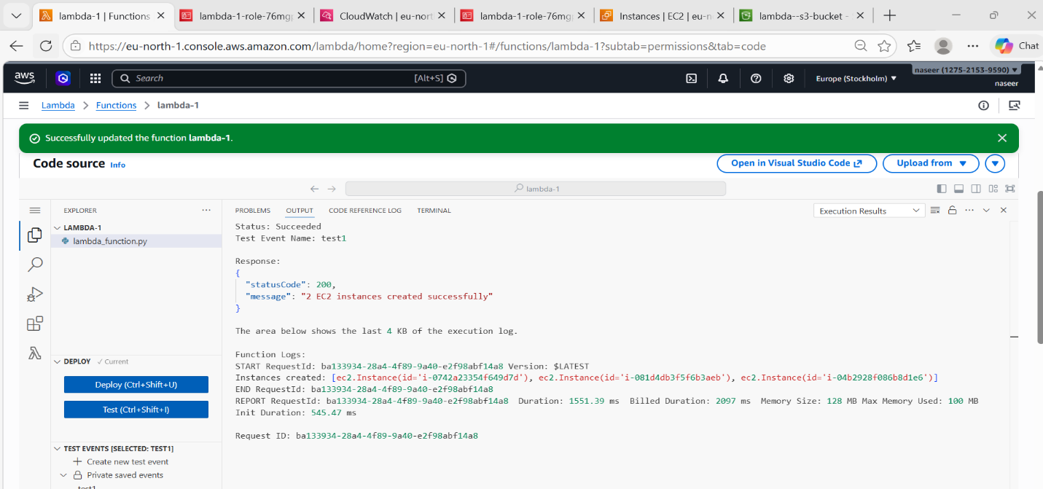
Verify EC2 Instances:
Go to EC2 DashboardClick InstancesYou should see 3 new instances running.
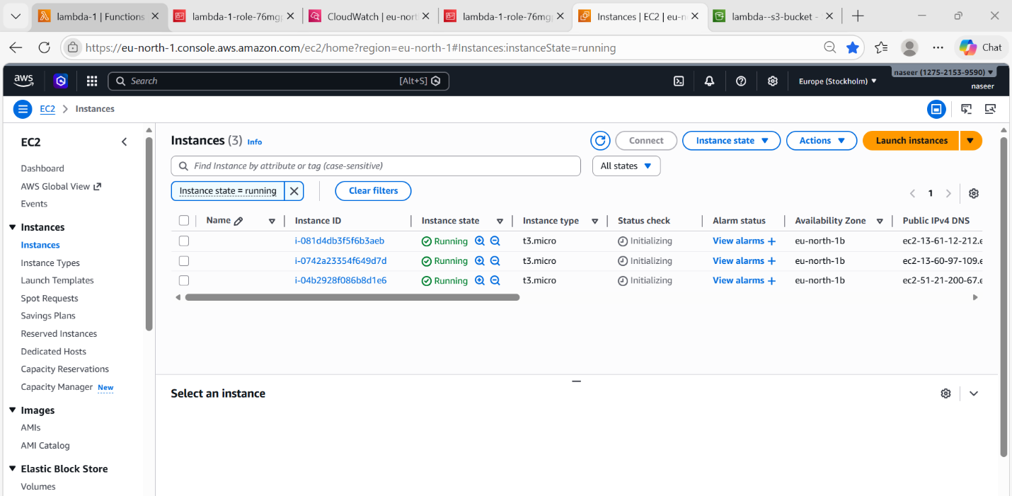

Final Working Architecture
User
↓
AWS Lambda
↓
Python Boto3 Code
↓
EC2 RunInstances API
↓
EC2 Instances Created

AWS API Gateway
Steps:
Login to AWS ConsoleSearch API GatewayClick Create API
Select HTTP APIClick Build under HTTP APIChoose Integration: Lambda
Then click Add Integration
- Select Lambda Function
Choose RegionSelect your Lambda FunctionClick Next
- Configure API Route
Now you define the URL path and method.
Example configuration:
Method : GET
Resource Path : /add
Meaning the API will look like:
https://5ofvcd909a.execute-api.eu-north-1.amazonaws.com/api-lambda/add
Click Next
Step 6 — Configure Stage
Stage means API version / environment.
Example:
Stage name : dev
Options:
Auto Deploy : Enabled
Then click Next
- Review & Create
API Name : api-1Integration : Lambda-1Route : GET /addStage : api-lambda
Click on CreateAPI will be created in 10 seconds.
- Copy Invoke URL
https://5ofvcd909a.execute-api.eu-north-1.amazonaws.com/api-lambda
Your final API endpoint will be:

https://5ofvcd909a.execute-api.eu-north-1.amazonaws.com/api-lambda/add

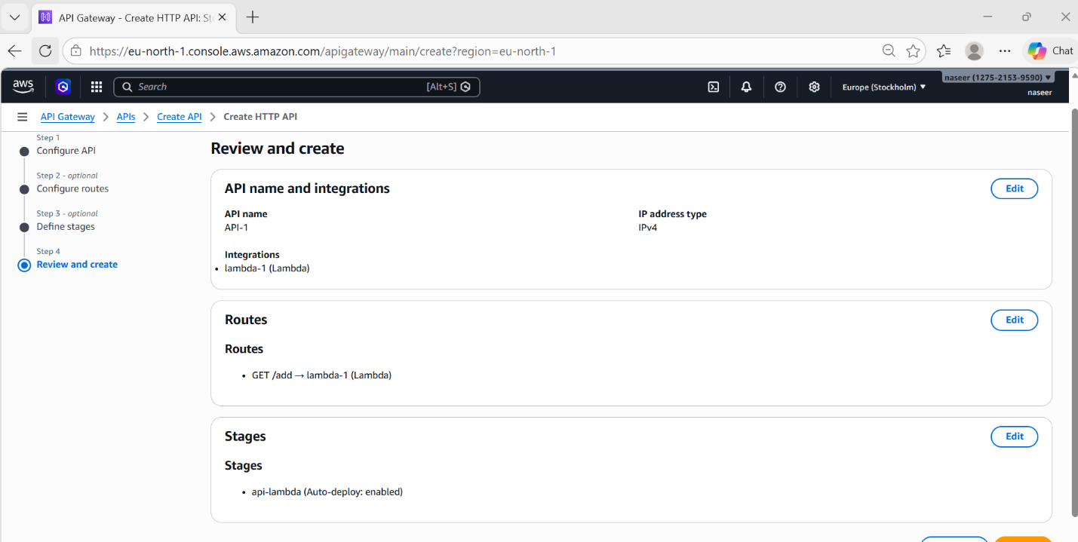

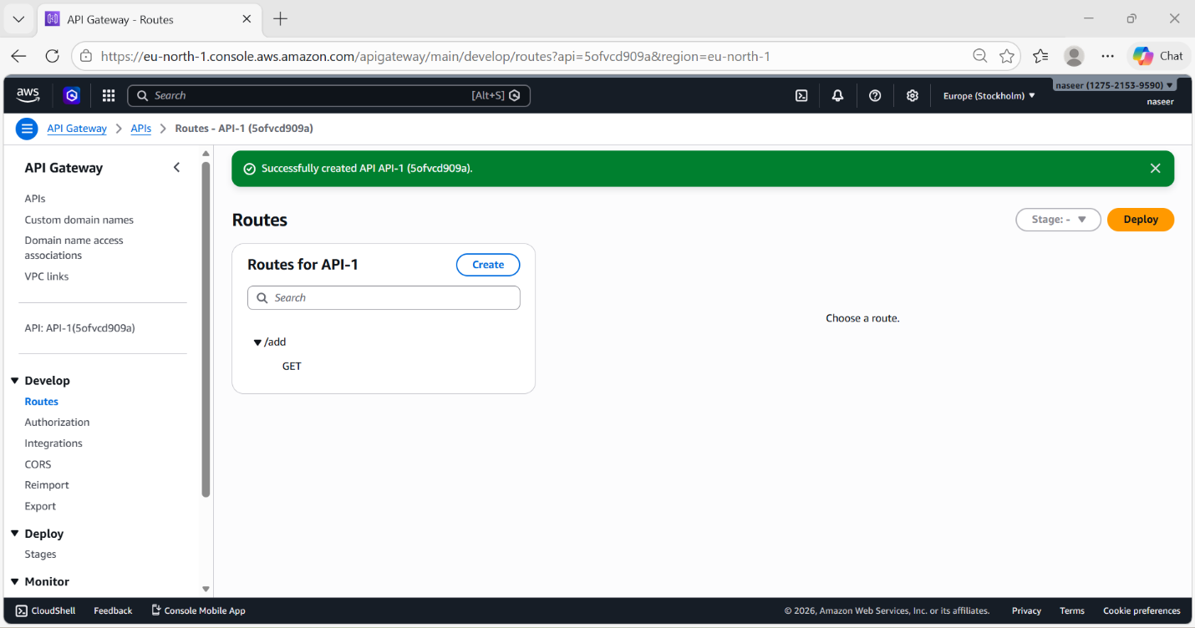
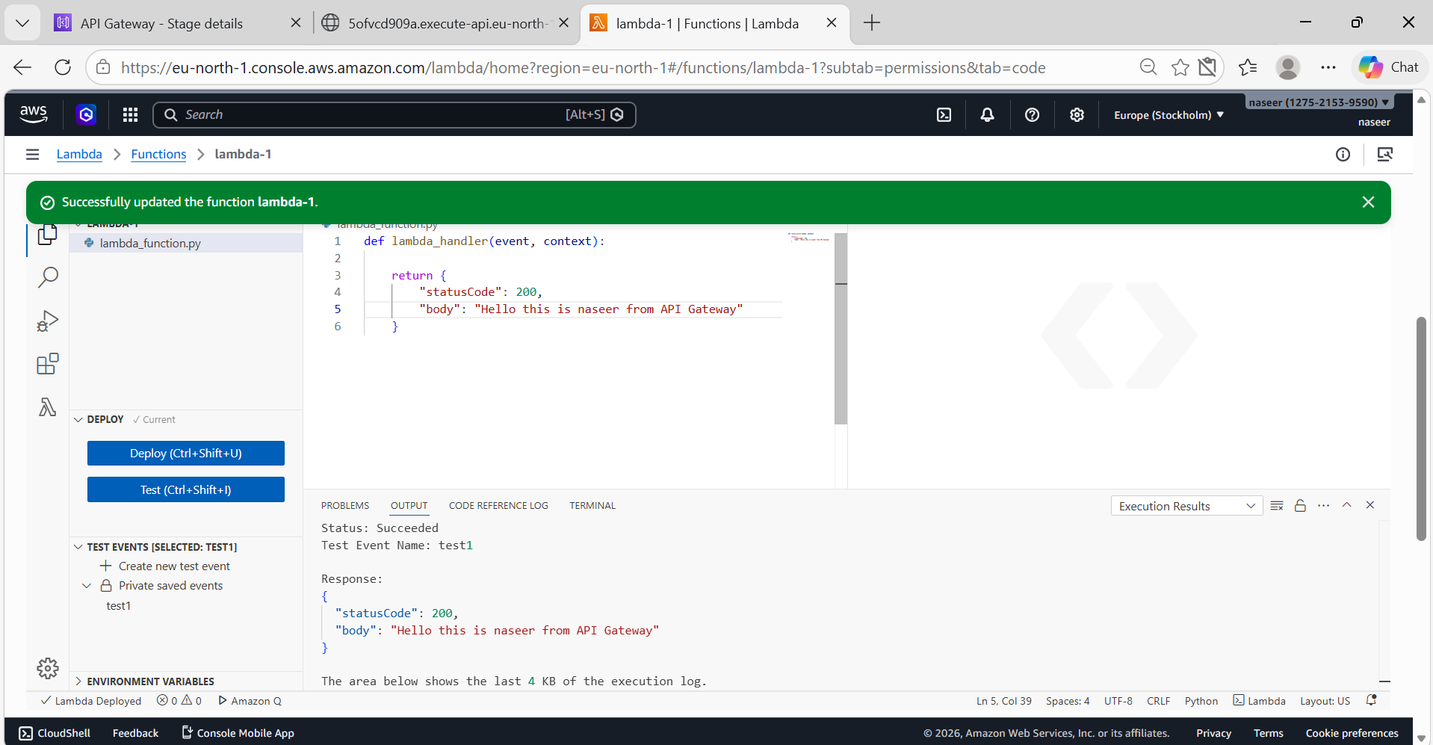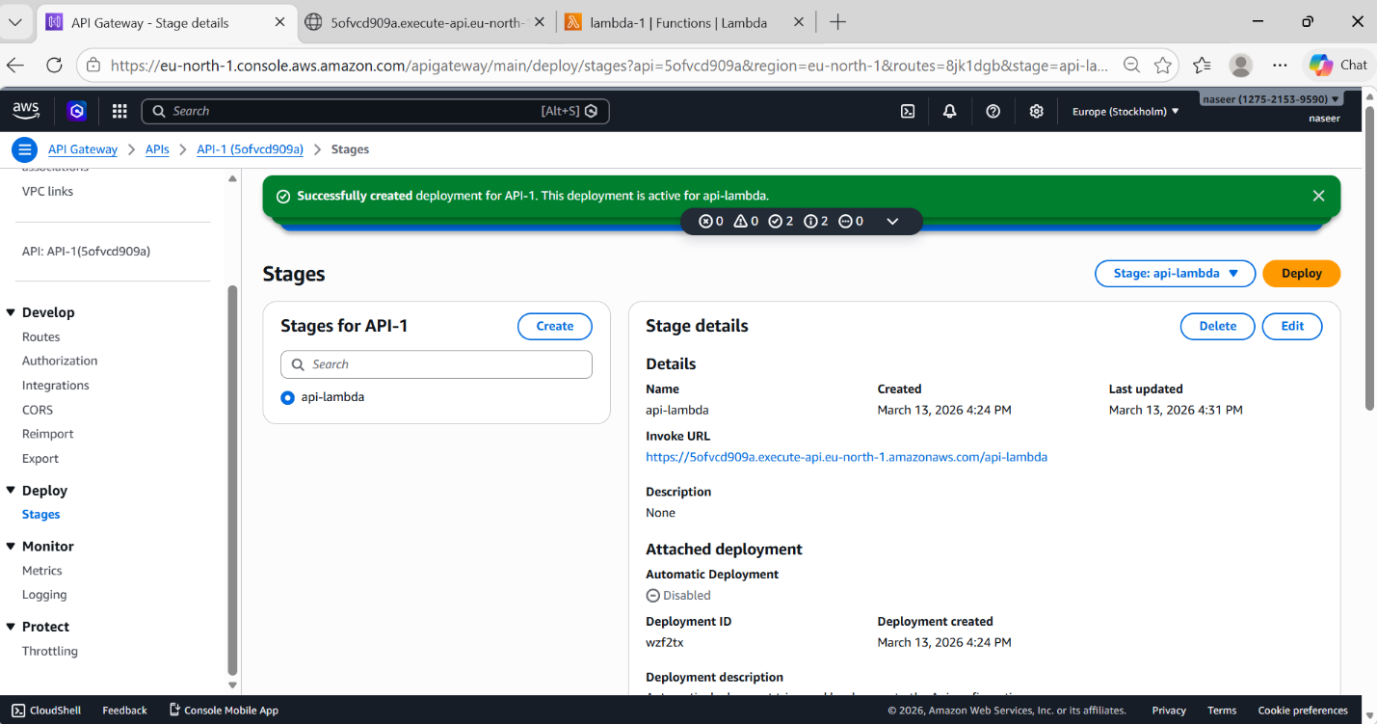
Go to Lambda
Code
def lambda_handler(event, context):
return {
"statusCode": 200,
"body": "Hello this is naseer from API Gateway"
}
Click Deploy and test
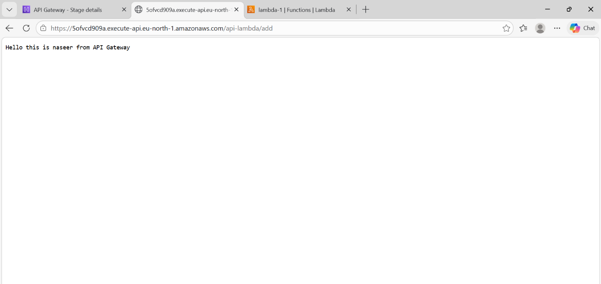
2) API Gateway File Upload
Architecture
Client
↓
API Gateway
↓
Lambda Function
↓
S3 Bucket
User uploads file → API Gateway receives request → Lambda processes → file stored in S3.

Steps:
- Create S3 Bucket
- Login to AWS ConsoleSearch S3Click Create bucket
Fill:
Bucket name: api-lambda-s3-bucket-789 Region: eu-north-1
Leave other settings defaultClick Create Bucket
Bucket created.
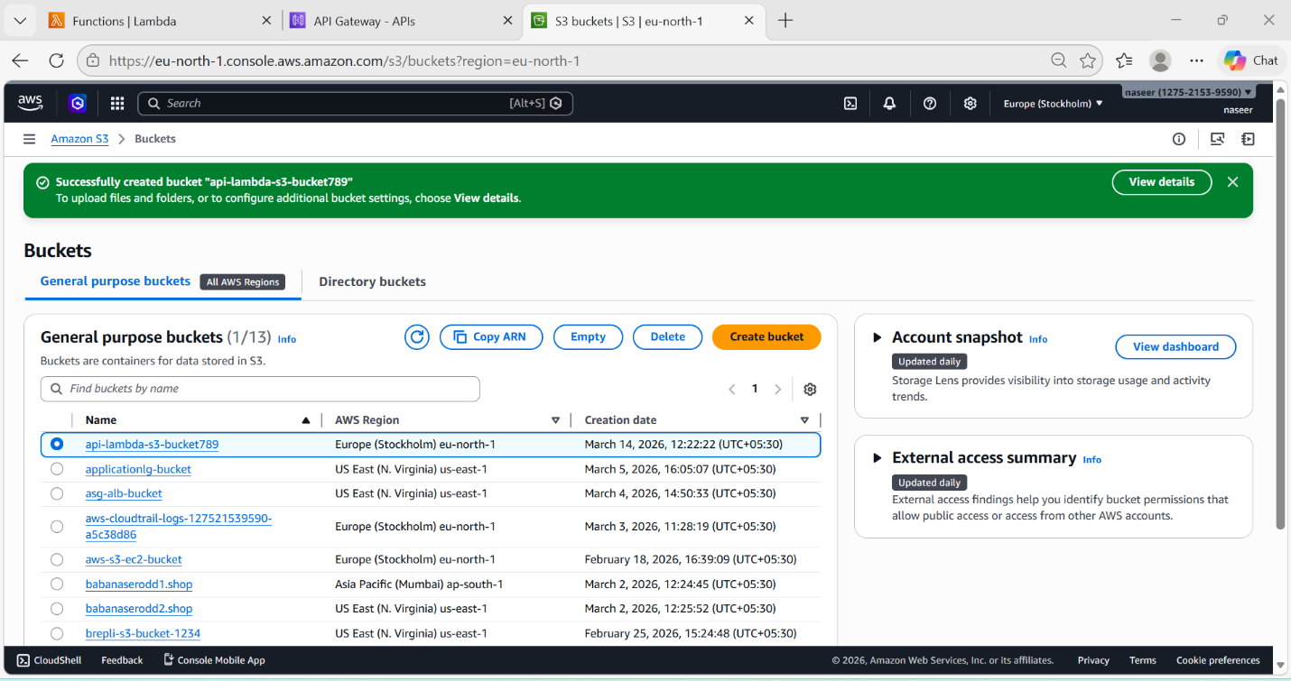
- Create Lambda Function
Go to AWS Console → LambdaClick Create Function
Choose: Author from scratchFunction name: lambda-1
Runtime: Python 3.12Architecture: x86_64
Click Create Function
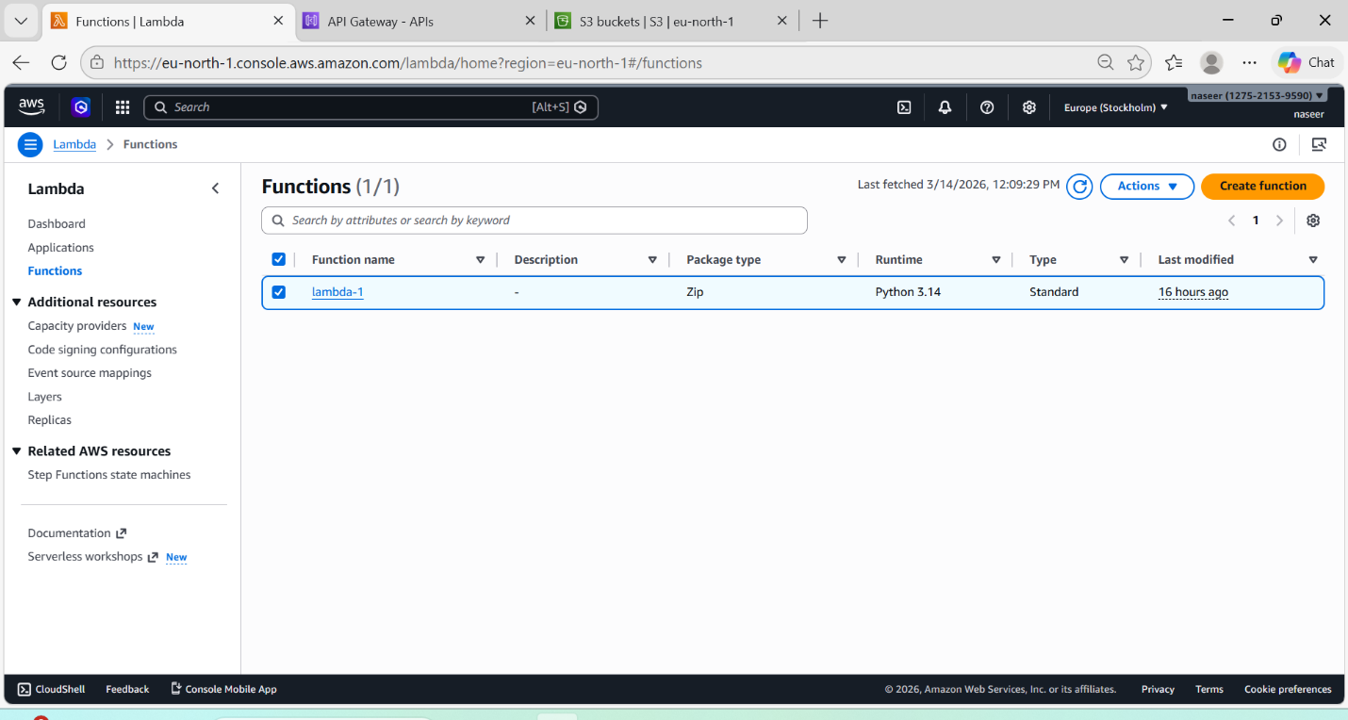
- Add IAM Permission
Lambda must have permission to upload to S3.
Lambda → Configuration → PermissionsAttach this policy: AmazonS3FullAccessSave.
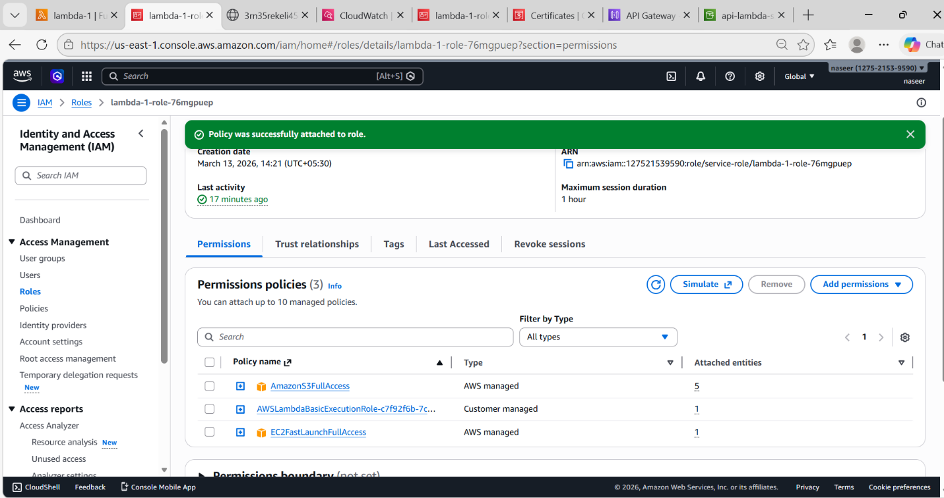
- Lambda Code
import boto3
import base64
import json
s3 = boto3.client('s3')
BUCKET_NAME = "api-lambda-s3-bucket-789"
def lambda_handler(event, context):
file_content = base64.b64decode(event['body'])
s3.put_object(
Bucket=BUCKET_NAME,
Key="uploaded-file.txt",
Body=file_content
)
return {
"statusCode": 200,
"body": json.dumps("File Uploaded Successfully")
}
Click Deploy
- Create HTTP API
Go to API GatewayCreate APIChoose HTTP APIClick Build
- Add Integration
Integration type: LambdaSelect Lambda: lambda-1Click Add Integration
- Create Route
Route: POST /uploadAttach integration: lambda-1Click Create
Click on Deploy
Create stage: Dev
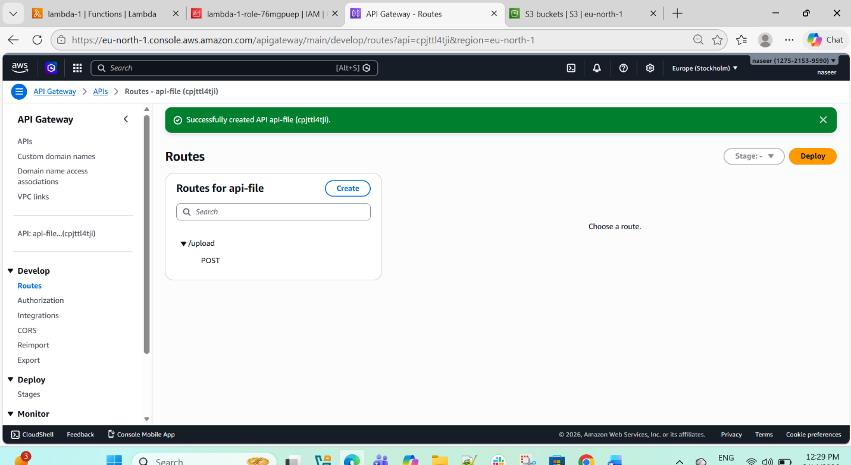
After deployment you will get URL like:
https://et611wfzm2.execute-api.us-east-1.amazonaws.com/S3/upload
- Test Upload (Using CURL)
curl -k -X POST \
-H "Content-Type: text/plain" \
--data-binary @file.txt \
https://cpjtt14tji.execute-api.eu-north-1.amazonaws.com/api-stage/upload

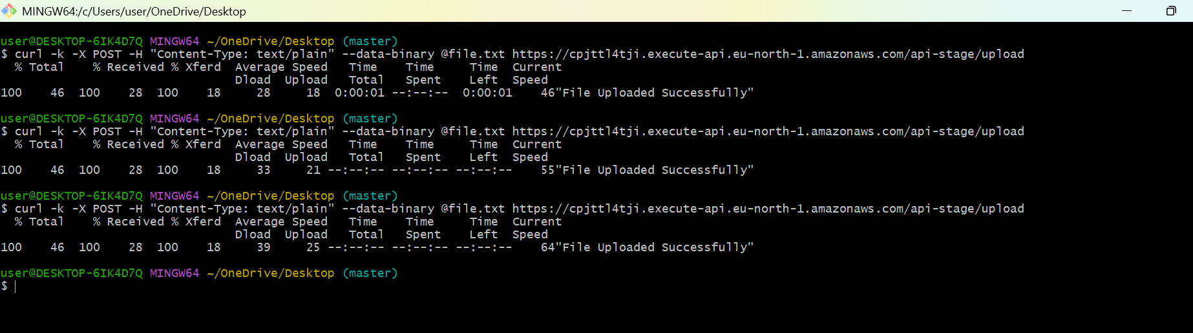

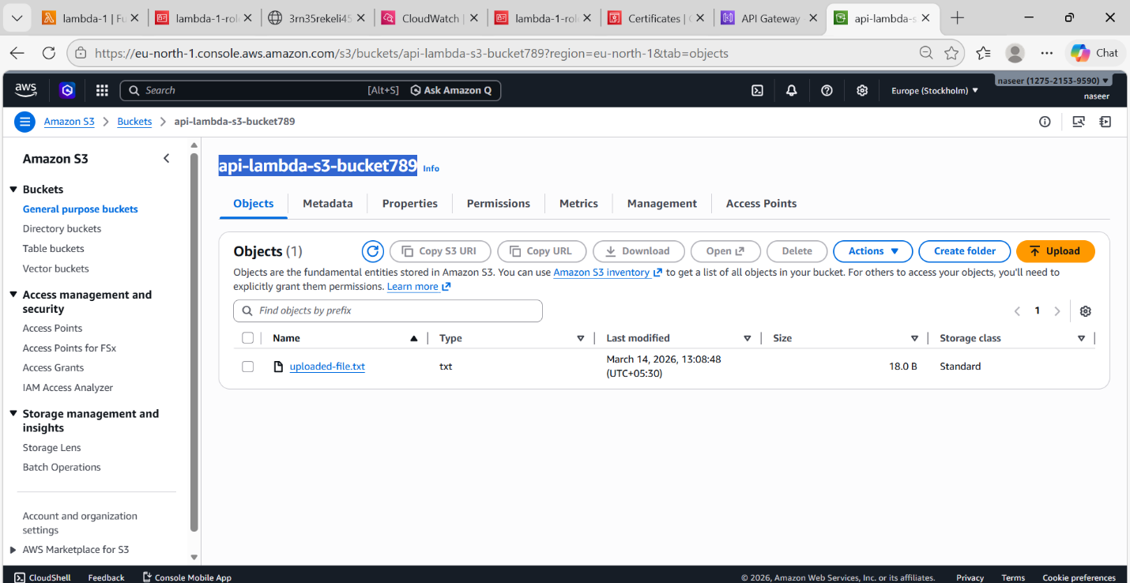
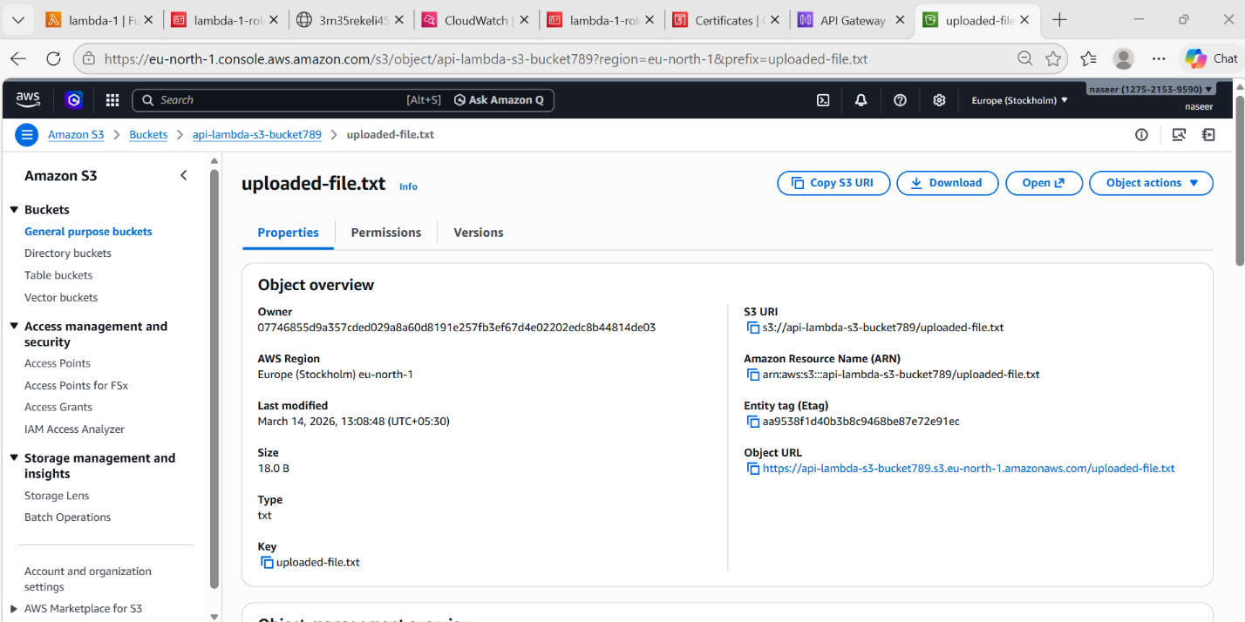
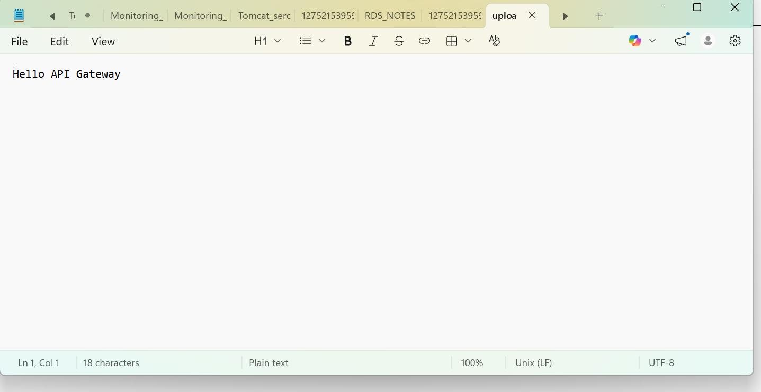

API Request Flow (What Happens Internally)
Client sends file
↓
API Gateway receives request
↓
API Gateway routes /upload
↓
Lambda triggered
↓
Lambda decodes base64
↓
Lambda uploads file to S3
↓
Success response returned

